Useful Numbers & Contacts
Badminton Group | Fran Pugh | 673429
Carpet Bowls | Jason & Jeannie Abdelnoor | 673651
St Mary’s Parish Church | Reverend Helen Savage | 676852
Slaley Methodist Church | Reverend David Goodall | 603139
St Elizabeth’s Catholic Church | Father Jeroen Hoogland | 673248
Commemoration Hall | Chairman Ros Doonan  Bookings Stella Douglas | 673173  673001
Community Trust | Chairman Norman Watson | 673914
County Councillor | Colin Horncastle | 618259
Craft Group
Dial –A-Ride | A.D.A.P.T | 600599
Film Club | Jean and Michael Elphick | 673443
Friends of Slaley School | Emma Turnbull | 673317
Hexham Hospital | 0344 811 8111
Ladycross Nature Reserve | Joan Jewitt | 673245
Leek Club | Malcolm Goodwin | 673408
Local History Group | Pat Wilson  Ian Hancock | 673388  673502
Mobile Hairdresser | Linda Johnston | 673196
Northumberland CC | Report faulty Streetlights/Potholes | 03456006400
Parish Council | Chairman Robbie Hutchinson  Clerk Pat Wilson | 673107  673388
Police PC Sue Cockburn | For non emergency calls please ring 101
Post Office Van | Martin Nichol  Stocksfield Post Office | 01661  842110
Rose & Crown Pub |  | 673996
Slaley Shop |  | 673201
Slaley First School | Head, Mrs Debbie Brett | 673220
Slaley Notes in  Hexham Courant | Stella Douglas  Helen Savage | 673001  676852
Slaley Parish Website | www.slaley.org.uk
Slaley Show Society | Chairman, Marge Rastall  Secretary Fiona Pattinson | 673547  07766 467 455
Slaley Red Squirrel Group | Margaret Bates | 673461
Travellers Rest Pub | Ian and Darren | 673231
Women’s Institute | President Margaret Rowell  Secretary Hilary Porteus | 673589  673637
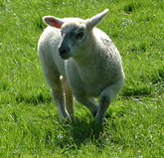
SLALEY NEWS
APRIL 2020
Please read this month’s news as it contains important information about the Community’s response to the current virus crisis

Slaley Rose & Crown

Reluctantly the pub has had to close its doors to customers but has decided to offer a take away service. Please phone 01434 673996 – unless you’re asking for help via the Pyramid of Care. (see back page).

Take Away Menu
Smoked Cod, Brie and Bacon Fish Cake, Chips and Peas £7.95
Beer Battered Fish and Hand Cut Chips, Tartare Sauce & Peas £9.95
Deep Fried Scampi and Hand Cut Chips, Tartare Sauce & Peas £8.95
Pie of The Day, Seasonal Vegetables, Choice of Potato & Gravy £8.95
Crown Burger, Bacon, Monterey Jack Cheddar and BBQ Sau £8.95
Crown Veggie Burger, Onion Rings & Fries £7.95
Cumberland Sausage, Chips or Mashed Potato, Vegetables £7.95
Mild Madras Curry, Chips or Rice £7.95

Sides Skin on Fries £2.95 Hand Cut Chip £2.95 Onion Rings £2.95

These prices are for takeaway only.
Children’s portions available - Ask when ordering

For orders please contact: Telephone 01434 673 996 – Delivery may be possible depending on your location.

Please ask a member of staff if you have any dietary requirements or allergies and we will be happy to accommodate.

Opening times are Monday, Thursday,Friday, Saturday,Sunday
12:00 - 2:00 pm and 5:00 - 7:30 pm

Contributions for the May edition by Friday 24th April please.
Editors: Jim Bailey 673352 baileyjim128@gmail.com
Fiona McKendrick: 673281 fionamckendrick@googlemail.com

In the current crisis it is best to assume that all social and club activities are on hold. These include the progressive dinner planned for June, Badminton, Bowls, History and Whist Clubs. Also Ladycross Quarry events and the Parish Council’s first aid course. Check with the organisers if in doubt.

Stocksfield Post Office and Mobile Service. Due to self isolation the Stocksfield Post Office is closed until April 6th and the mobile service will not be visiting the village.

Are you creative but looking for projects to fill in your time? Hexham and Slaley Arts and Crafts. www.hasac.org.uk have some interesting projects for you to while away any boring or lonely times. You will be able to submit pictures of your efforts which will be displayed on line.

Hedgehogs. As spring approaches and days get warmer watch out for Hedgehogs coming out of hibernation. In 2019 the Hexham Courant reported that at least half our Hedgehog population has been lost in the last two decades. Jacqui Clarke runs the Dipton Hedgehog Hotel rescue and rehabilitation centre, near Consett in County Durham. (Pontop Hall, Dipton DH9 9ED Tel 447738487781). Carole Catchpole meanwhile is the founder of the Northumbria Hedgehog Rescue Trust based at her home in Longframlington. (Harrogate Lane, NE65 8EA 01665 570911)
If Hedgehogs visit your garden you should consider yourself very lucky and give them a helping hand by leaving a dish of mealworms & dried cat food along with a shallow saucer of fresh water. Hedgehogs will travel up to a mile every night in their quest to find food and a mate. If you find a hedgehog out in the daylight the chances are it needs help. The only exception to this rule is if it’s a nursing mother, which should be looking well and moving with purpose.
As part of our Community Environmental Project we are recording the number of Hedgehogs in the area. If you see a Hedgehog please record your sighting by emailing Pat Wilson on pat.wilson28@outlook.com. If you find an injured Hedgehog please telephone either Carole or Jacqui.

Alien Invasion!
The Community Environmental Group are asking for your help in reporting non-native plant species which are thriving in the UK and threatening our native flora and fauna.
Japanese Knotweed costs £166m a year to deal with and the swift-growing plant’s ability to grow through concrete, house foundations and roads causes untold misery for many. Introduced into the UK in the early 19th century as an ornamental plant it is now widespread across the country.
If you are unsure take a photograph on your mobile and email to Slaley Parish Council Clerk with an indication of the area – proximity to house name/road/burn etc. pat.wilson28@outlook.com
.
Slaley’s Pyramid of Care – how we can help you

Slaley Parish Council, Slaley Community Shop and other community groups have joined forces to ensure that everyone’s needs in our community are met and no-one is forgotten: Slaley’s Pyramid of Care.

It works like this: We’ve divided the parish into clusters, based on the way you receive Slaley News. Each cluster has an area rep. who will make contact with every household.

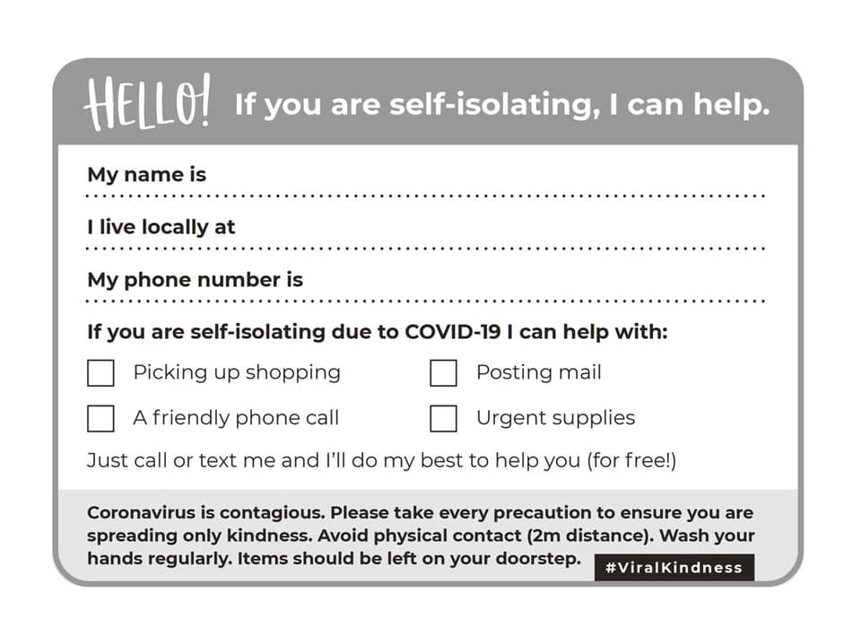
If you are self-isolating or unable to go out for any reason and need help with shopping, especially from Slaley Community Shop, posting (necessary) mail and collecting other urgent supplies; or if you’d just welcome a friendly chat on the phone, please let your area rep know.

You’ll find a copy of this card in Slaley News with details of who your area rep. is and how to contact them.

Your area rep. will then, in turn, contact Olwen Savage who will arrange for someone to attend to your needs.

We won’t, of course, be able to do everything; for example, we won’t be able to offer you nursing care, but we’ll do our utmost to help.

If you need shopping your volunteer helper will assist you to make arrangements to pay for it. Slaley Shop welcome cheques, BACS payment and cash and we have also found a way to accept card payments. BUT, please don’t hesitate to get in touch even if you have no money now to settle a bill - we will always do our best to help.

We are also working with our two pubs – the Rose and Crown and Travellers Rest to arrange delivery of hot take-away meals if you are unable to cook for yourself.

We already have a list of volunteer helpers, but we need more folk still, especially if some of us become ill and have to self-isolate ourselves. If you can offer some time, please contact Olwen (01434 676852 or email olwensavage@gmail.com).

In all that we do, we’ll also adhere to strict and proper hygiene standards – so please think about a safe space where we can leave deliveries!

2020 Annual Parish Litter Pick and Alien Species Identification/Report

At the moment this is scheduled to take place as it is an open air event.
Slaley Parish Council invite members of the public, who have ever complained about the litter left lying in and around our parish, to join on Sunday April 19th 10.00 a.m. – 12.00 noon. Meet at Slaley Commemoration Hall
Gloves, Bags, Litter Grabbers, Alien Species Leaflet & Traffic Warning Signs will be provided.
There is a Prize for the most unusual item collected during the morning.
In the case of adverse weather, the Litter Pick will be postponed.
A copy of the Risk Assessment will also be given to volunteers.

Slaley Show cancelled

It is with great regret that I am writing this to let you all know that the committee have had to make the really difficult decision to cancel this year’s Slaley show that was due to take place on Saturday 8th April. We are all very saddened by this but it seems very clear that the spread of the coronavirus at large public gatherings poses a significant risk to health and we fully comply with the government’s guidance to defeat this disease. We look forward to seeing you in 2021 with a bigger and better show! Thank you all for your continued support.
Hope you all stay safe and well at this awful time

Fiona Pattinson Slaley Show Secretary

Marge Rastall, Show Chairman adds

However, if there is an improvement by 8 August the committee will arrange some sort of village event. I expect by then everyone will be keen to enjoy themselves. In the meantime, please keep yourselves, your loved ones and the community safe.

Slaley and Hexhamshire Oil Buying Group

The March order achieved a tremendous price of 32.6 pence per litre plus 5% vat, the lowest for 2 years, thanks to the Russians and Saudis squabbling over price and Market share
Our volume in March was 51,600 litres which meant a saving of £3,911 over the second competitive price which was 40.18 ppl plus vat
Deadlines for the April order will be orders to me by Tuesday 14th April for delivery during week commencing 20th of April
Thanks for your continued support and keep safe everyone
Neil Whatmough.

Slaley Churchyard

The churchyard has been looking so lovely lately with beautiful snowdrop clusters and soon the daffodils will do their bit!!
There are many jobs need doing to keep this lovely space so beautiful. Right now all the branches from the winter winds need collecting so we can start the grass cutting. If you can spare some time just do it, it will really be appreciated!
If you would like to help with the grass cutting over the summer please get in touch. This job can turn into a chore but with a few helpers it is a rewarding task!
Brian 673043

Slaley garden column April 2020 Karen Melvin

In the veggie garden seedlings are ready to be pricked out and put in pots, and more seeds sown, thinking forward to fresh garden veggies. Even better, April brings the first of the woodland carpets. Letah Wood has wild daffodils and Allensford has wild garlic coming up along the river. Watersmeet, the SSSI on the North Tyne near Acomb, has wonderful flowers from snowdrops in February to carpets of wood anemone, then daffodils and bluebells and taller meadow flowers in summer, all next to the beautiful North Tyne river and its dramatic rocky edges.

My wild garden, which was planted on rocky quarry back-fill under old trees, is a lush carpet of bulbs and hellebores with the first of the cherry blossom coming out. Cherry blossom is the first real exuberant pink of the season. The wild cherries here are huge trees now and the simple white flowers fill our vision overhead. I appreciate the Japanese feeling for cherry blossom, called Hanami, where families and friends sit and picnic under cherry trees. Cherry blossom is fleeting and reminds them to “pay attention” to the beauty of ephemeral things. There is even a word for a cherry blossom floating down and touching a person and a cherry blossom blizzard, sakura fubuki.

I look out for biennial honesty which seeds itself in the border. I grow three kinds of honesty, the plain purple one in the wild garden, and more spectacularly a purple flowered and a white flowered variegated leaf types. If they survive the winter and my partners weeding efforts, they light up the early border when not much is happening. They seem to migrate around the garden looking for good soil to thrive in, surprising me, sometimes delightfully if there is a mass of them.

Notes from the Vicarage

Fairly soon after their escape from the Egypt, the people of Israel began to realise just how tough life might become for them now. Their basic needs weren’t met and they were unhappy. Twice they had a problem finding any drinking water.

In the Ancient Near East the availability of water – essential for life and well-being – was closely linked with the idea that God was closely present.

So when no water could be found, the people of Israel felt that God had deserted them. They found it hard to see beyond their basic, immediate needs.

In 1943 the very influential Jewish American physiologist Abraham Maslow published a theory suggesting that we humans have a hierarchy of needs.

He argued that basic needs such as air, water, food, and shelter must be met first before people can move on to gain respect and self-esteem, let alone the ability to enjoy and recognise beauty or to have a religious faith.

Over the years his theories have had to be revised. It’s very evident that there are great artists who have lived in poverty and yet created works that help us to see life differently; and there are people who can be happy and feel a sense of fulfilment even when they’re hungry, scared or threatened. It is not the case that when no water can be found that God has deserted us. The people of Israel eventually learnt this lesson and gained the courage, despite regular setbacks, to continue their quest to find their promised land.

People are resilient and resourceful; we are surprisingly good at rising above the difficulties we encounter, as I’m sure we’ll rediscover over the coming weeks, when it may feel that our more basic needs for safety and well-being are ever more under threat.

And a sense of perspective really helps, whether that’s explicitly religious or one that’s gained through the wonder that the arts or music can bring.

As I tried to take in the scale of the problem presented by Coronavirus, one evening recently, I collapsed into a chair and listened to some remarkable and very wonderful piano music written in 1892 by Brahms – his Op 116 Fantasias, written as the aging composer tried to come to terms with his own mortality and the death of many of those close to him. These pieces are at times deeply sad, they don’t make light of pain, and yet they are full of a spirit of defiance and a fierce passion. For me they speak of hope, not despair. And as I listened and let the music take me over, I was reminded again just how much human relationships matter - more even than personal protection. And I remembered St John’s assertion that love has the ability to cast out fear.

Whatever may happen to us over the coming weeks, may God be with us and give us strength.

The Church is Open!

We aren’t allowed to hold public worship in church until further notice, but we haven’t stopped praying. Every Sunday Helen will circulate some ideas for private devotions – prayers, readings and a reflection on them. If you’d like to receive these, please ask (email Helen on helensavage1@gmail.com). Paper copies will also be available and they’ll also be posted on our website: www.moorland-group.org.uk

In addition, we’re going to stream a simple act of live worship, every Sunday morning at 10.30am on a new Facebook page. We’ll try to do this from a different church in the group every week. You don’t have to watch it live – it’ll be there on the Facebook page for whenever you want it. You can find the new Moorland Group Facebook page at https/www.facebook.com/moorlandgroup/

You may also hear the church bell ringing in the morning and evening, normally at around 9am and 5pm. This is a sign that people in our villages are praying – for you, for one another and for the needs of the world.

Finally, we’ve considered the possibility of holding a simple act of worship outdoors on Easter Day. This would be in the churchyard extension at Slaley at 11am. Of course, we’ll have to abide by whatever rules may then be in force about staying at home and social distancing, which is why this can only be a provisional arrangement. The latest position from the national church is to say that it may not be possible, but if we can go ahead, we will. Watch out for notices on the noticeboards, via email, Facebook and the website.

Slaley Community Shop News

We’re doing our utmost to keep the shop open and stocked. At the moment the latter is proving a little more difficult than the former, just as our sales have seen a huge upturn. Please bear with us if we can’t always supply some of things that every retailer is struggling to keep on the shelves (loo rolls, paracetamol, pasta and so on). We’ve also had some problems with bread supplies and even our wonderful frozen meats, but we‘re confident that both these will be back to fairly normal before long.

We’re sad that some of our older and wiser volunteers can’t be on duty at the moment, but delighted to welcome a host of younger faces. Welcome to our team (and well-done Paul, Barbara and others for a heroic act of staff training)!

.

