Slaley, Healey & Minsteracres Local History Group

Quakers and the Lead Mining Industry of the

North Pennines

By David Penn
Monday 23rd March 2026

7.30 p.m. Slaley Commemoration Hall.

£4 adults 50p anyone in full time education.

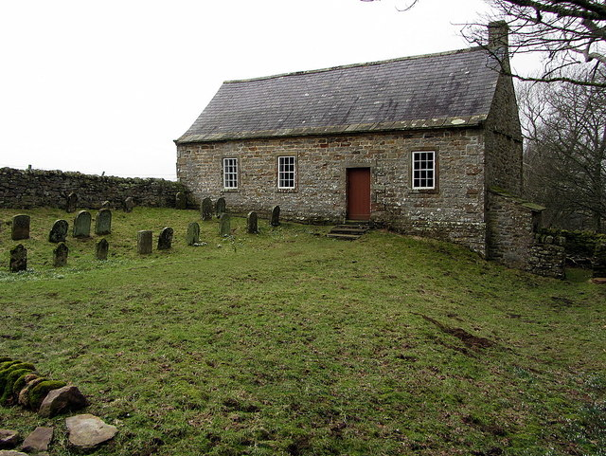
Coanwood Meeting House
In September 2025 the Hexham Courant carried a photograph and article entitled “Book reveals religion’s ties to local lead mining”. The Book was launched on August 23 during a weekend of celebrations marking the 200th anniversary of the construction of Nenthead Mining Village by the London Lead Company in 1825. David Penn was the author and I got a copy of his book from Cogito in Hexham. The photograph above is the 1760 Coanwood Quaker Meeting House and Alex (my daughter) and I attended a Christmas Fair inside this small building on a very wet morning of Sunday December 7th 2025.
According to David “Quakerism emerged from the turmoil of the English civil war (22/8/1642-3/9/1651), first taking root in the upland areas of northern England.” Page 5
As a group we have briefly heard about local Quaker practices in September 2019 when Hugh Richardson gave his ‘Wheelbirks’ talk and during my ‘Healey’ talk in November 2024 when the Blanchland meeting house and gravestones were discussed. The Lead Trade has never been far from our talks being as we were involved with the Smelters and Carriers Project and live so close to Dukesfield Smelt Mill.
David’s talk will combine the two subjects, Quakerism and Lead Mining. We already have a little knowledge so the talk should lead to lots of discussions.

For more information contact Pat Wilson 01434 673388, email: pat.wilson28@outlook.com

